- Microevolution explains evolutionary changes within the gene pool of a population. It takes place over relatively short periods of time.
- Macroevolution considers speciation, the origin of new species. It takes place over long periods of time.

- Reproductive isolation preserves the genetic integrity of a biological species. This results from barriers that prevent individuals of different species from producing viable, fertile hybrids.

- Prezygotic barriers function before fertilization takes place. These barriers prevent successful mating between different species.
  - Habitat isolation occurs when two species live in the same area and occupy different habitats
  - Temporal isolation occurs when two species breed at different times
  - Behavioral isolation occurs when courtship rituals and behavioral signals are species specific
  - Mechanical isolation occurs when anatomical incompatibilities prevent mating with members of other species
  - Gametic isolation takes place when the gametes of different species fail to fuse, due to mechanisms such as the inability of sperm to penetrate the membrane around the egg.
- Postzygotic barriers function after fertilization happens. Postzygotic barriers prevent offspring from developing into viable, fertile adults.
  - Hybrid inviability describes a situation where a hybrid zygote fails to survive embryonic development
  - Hybrid sterility, occurs when a viable hybrid individual is sterile
  - Hybrid breakdown occurs when the hybrids are viable and fertile, but their offspring are feeble or sterile.
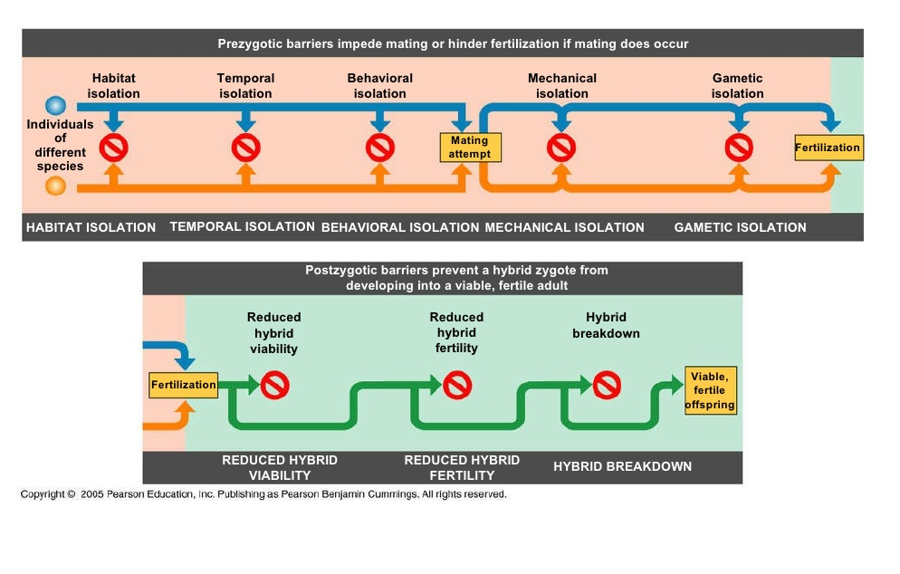

- Adaptive Radiation is the evolution of numerous, variously adapted species from a common ancestor introduced into an environment with many new ecological niches. Colonization of newly formed islands or the opening of numerous niches following mass extinctions may provide the opportunity for multiple speciation events.
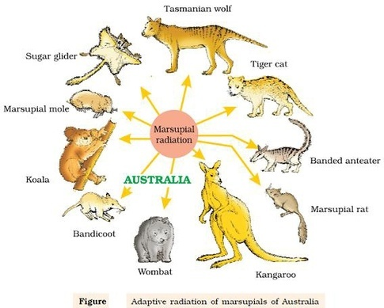
The Tempo of Speciation
In the fossil record, new forms often appear rather suddenly, persist unchanged for a long time, and then disappear. According to the model of evolution known as punctuated equilibrium, long periods of no change are punctuated by episodes of rapid speciation and change. In geologic time, the thousands of years during which a species evolves is small compared with the millions of years a successful species may exist, and this short period of divergence may not be captured in the fossil record.
Evolution of the Genes That Control Development
- Heterochrony is an evolutionary change in the rate or timing of development.
- Paedomorphosis is the retention in the adult of juvenile traits of ancestral organisms and can occur when genetic changes speed up the development of reproductive organs relative to the development of body form.
Changes in genes that control the spatial arrangement of body parts have also been important in macroevolution. Homeotic genes determine where basic body features develop. Mutations in homeotic genes called Hox genes, whose products provide positional information in embryos, can drastically alter body form. Duplications of the Hox complex of invertebrates may have been central to the evolution of vertebrates.

