PBS Evolution
The Evolutionary Arms Race

Predator and Prey

- What unusual adaptation does the rough-skinned newt have?

- The common garter snake is able to prey on the rough-skinned newt. Does it suffer any ill effects?

- Is there any disadvantage of the snakes having resistance to the toxins?

Antibiotic-Resistant Tuberculosis
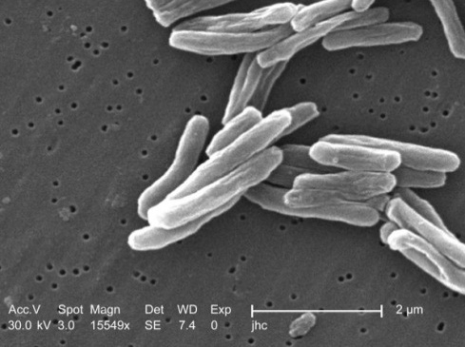
- Are micro-organisms predators? Explain.

- What discovery gave humans an advantage over bacteria?

- What does tuberculosis do in the body when active?

- How does tuberculosis spread from person-to-person?

- Explain the events that led to the evolution of antibiotic-resistant TB in the prisoner.

- How are prisons ideal incubators for multi-drug resistant TB?

- Why aren’t second-line antibiotics available for use in the prisons?

- One of the scientists describes multi-drug resistance as a “man-made problem”. How are they over-used?

AIDS and FIDS

- What normally-fatal disease is found in nearly every wild cat in the world?

- This disease is considered to be non-lethal in wild cats. What is the proposed explanation for this?

- About 10% of Caucasians are immune or resistant to HIV. What event occurred in Europe that may have created selective pressure for this trait?

Symbiosis

- Define mutualistic symbiosis –

- Give one example of mutualistic symbiosis.

- Describe the relationship between the Atta leaf-cutter ants and the fungus they cultivate.

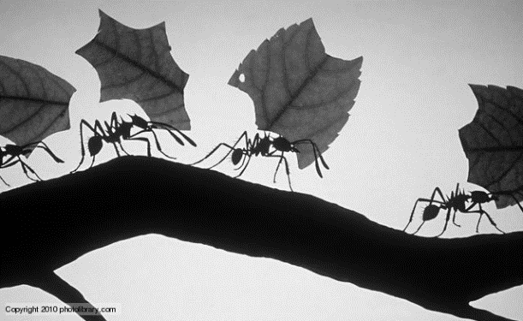

- What pest invades the fungus gardens that the ants maintain?

- Why don’t the fungus gardens develop resistance to the bacterial antibiotic?

Allergies and Asthma

- In the study of asthma rates of children living in the Bavarian countryside, what factor seemed to lower the rates the most?

- Do you think it is unnatural or unhealthy to expect to live in a germ-free world? Explain.

