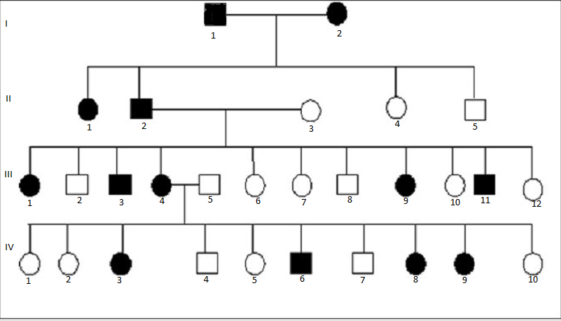
____
____

____
____
____
____
____

____
____
____
____
____
____
____
____
____
____
____
____

____
____
____
____
____
____
____
____
____
____

Fill in the pedigree above as completely as possible. Is the trait in question most likely autosomal recessive, autosomal dominant or X- linked?

What is the probability that Individual I-1 and I-2 would have an offspring that displays the trait in question? (Show Punnett square to support your answer)

What is the probability that Individual IV-10 would have an offspring with the trait in question if she mated with a male that did not display the trait? (Show Punnett square to support your answer)

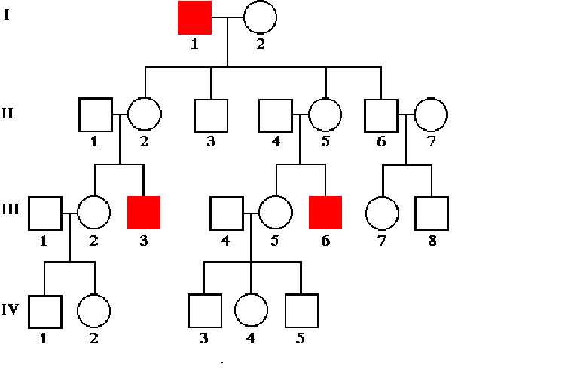
____
____

____
____
____
____
____
____
____

____
____
____
____
____
____
____
____

____
____
____
____
____

Fill in the pedigree above as completely as possible. Is the trait in question most likely autosomal recessive, autosomal dominant or X- linked?

What is the genotype of individual I-1? I-2? II-1? II-2? What are the possible offspring of Individuals II-4 and II-5? What is the probability of having each possible offspring? (Show Punnett square to support your answer)
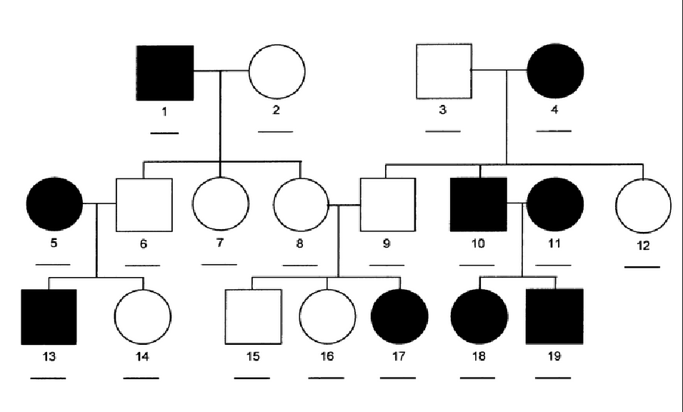

Fill in the pedigree above as completely as possible. Is the trait in question most likely autosomal recessive, autosomal dominant or X- linked?

What is the probability that Individual 8 and 9 would have an offspring that displays the trait in question? (Show Punnett square to support your answer)

What is the probability that Individual 5 and 6 would have an offspring that displays the trait in question? ? (Show Punnett square to support your answer)

What is the probability that Individual 10 and 11 would have an offspring that displays the trait in question? ? (Show Punnett square to support your answer)

Construction and use of a Pedigree
You are a genetic counselor who has been given the following information from which your will construct a pedigree:
- Your data: Henry has a double row of eyelashes, which is a dominant trait. Both his maternal grandfather and his mother have double eyelashes. Their spouses are normal. Henry is married to Isabella who also has normal lashes and their first child Polly has normal eyelashes. The couple wants to know the chances of any future child having a double row of eyelashes.
- Construct two blank pedigrees. Begin with the maternal grandfather and grandmother and end with Polly.
  - Pedigree 1: Try out a pattern of autosomal dominant inheritance by assigning appropriate genotypes for an autosomal dominant pattern of inheritance to each person in this pedigree.
  - Pedigree 2: Try out a pattern of X-linked dominant inheritance by assigning appropriate genotypes for this pattern of inheritance to each person in your pedigree.
Pedigree 1

Pedigree 2

- Which pattern is correct? ______________________

- Which of the Pedigrees above is correct? _____________________________
- How do you know (cite specific evidence from your pedigree)?

- What is your key for this trait?
- What is the genotype of Henry _______________ and Isabella? _________________

- What gametes can each of them make?

- What is the probability of Henry and Isabella having a child with double eyelashes (Show the Punnett square for evidence)?

